|  |  |  |  |  |  |  |  |  |  |  |  |  |  |  |  |  |  |  |  |  |  |  |  |  |
| --- | --- | --- | --- | --- | --- | --- | --- | --- | --- | --- | --- | --- | --- | --- | --- | --- | --- | --- | --- | --- | --- | --- | --- | --- |
| |  |  | | --- | --- | | For office use only | | | T1 | ________________ | | T2 | ________________ | | T3 | ________________ | | T4 | ________________ | | |  | | --- | | Team Control Number **19988869** | | **B** | | |  |  | | --- | --- | | For office use only | | | F1 | ________________ | | F2 | ________________ | | F3 | ________________ | | F4 | ________________ | |

**IMMC 2019**

**The 5th Annual International Mathematical Modeling Challenge (Autumn Contest)**

**Summary Sheet**

The economists design a wordplay game to research the impact of the self-control mechanism to the game. In this essay, we construct mathematical models to investigate the impact of self-control to the online gameplaying.

In our model A, we do some preparation work. We rank the different ranks of addiction in different gameplaying time to calculate the addiction index later. We also classify the games according to their continuity and repeatability for they have different game contents. Besides, we also rank the games according to their social networking function. These works will lay the ground for our later work to discuss the different between games.

In our model B, we build models which involve the playing time, the player’s quality and the competition to qualify the addiction degree of a player to the game. We compare the addiction index before using the self-control mechanism with the one after using it to get the effect.

Then we discuss the set of the self-control mechanism in different types of games according to our classifying in our model A. We dividedly investigate the interest of these games. We consider the harm of the computer radiation and the joy the players get and research the optimum mechanism to change the reap that the players gain in the games to work as a nudge to incentivize the players’ self-control.

Finally, we do the sensitivity analyses to show the robustness of the models and write a proposal letter to a game production company to set the optimum mechanism for the game.

|  |
| --- |
| Control yourself from the Gameplaying  Team#19988869  Nov.20, 2018 |

Contents

1. Introduction 4

1.1 Background 4

1.2 Problem Restatement 4

1.3 Literature Review 4

2. General Assumptions 4

3. Model A: Preparation Model 5

3.1The Degree of the addiction and the Time 5

3.2 The Game Ranking according to Sociality 5

3.3 The Classify of the Games 6

4. Model B: Establishment of the Index of Addiction 7

4.1 Model Overview 7

4.2 Variables of Model B 8

5. Model C: Games with Networking 11

5.1 Model overview 11

5.2 Variables of Model C 11

5.3 Social factors 11

3. 5.4 Continuous and Social 12

5.5 Life Span 14

6 Sensitive analysis 16

6.1 Sensitivity of tq 16

6.2 Sensitivity of tar 18

7. Strengths and weaknesses 18

7.1 Strengths 18

7.2 Weaknesses 19

8.References 20

9.A Proposal letter to a Game Production Company 21

1. Introduction

## Background

Nowadays, online game addiction has become a serious problem that worth thinking. Some people immersed themselves into games, others who have self discipline are eager to figure out a way that can restrict their game time. Therefore, a research whose span is 84 months has been established. The game in the experiment is a leisure-type repetitive online scrabble board game. Each round of game lasts for 3 minutes. An interval of 45 seconds between two rounds is set for rest. Two types of self-control commitment devices are built in the game: "before-game" self-control device and "in-game" self-control device.

## Problem Restatement

We are required to build models of the behavioral change of online game influenced by the self-control devices and propose solution of self-restraint system for anti-addiction of excessive online games.

1. Analyze the data to figure out the influence of the mechanism of self-control to people’s behavior.
2. Compare the difference between "ex-ante" self-control device and "in-game" self-control device.
3. Find out how do the mechanism of self-control influence the life span of a game
4. What should be adjusted if strong social networking and longer online games are involved.

## Literature Review

The economists design a wordplay game to research the impact of the self-control mechanism to the game. In this essay, we construct mathematical models to investigate the impact of self-control to the online gameplaying. Online game addiction has become a serious problem that worth thinking. Some people immersed themselves into games, others who have self discipline are eager to figure out a way that can restrict their game time.

1. General Assumptions
2. We define a turn of game as a game played in a pried of time.

For we can easily count and deal with the data, we define a turn of game as a pried of continuous time during which the player plays it.

1. We don’t consider the people who stay at home whole day.

Since this kind of people is very rare, we don’t take them into consideration.

3. We use a minute as the minimum unit.

The minimum unit given in the subject is a minute.

3. Model A: Preparation Model

3.1The Degree of the addiction and the Time

First, we rank the degree of addiction when a player plays the game in different moment. For instance, we often think that a man who plays game at 12.00 pm must be more addictive than the one who plays game in the same intension at 12.00 am. In this way, we get the relation of the addiction degree and the time through the function figure below:

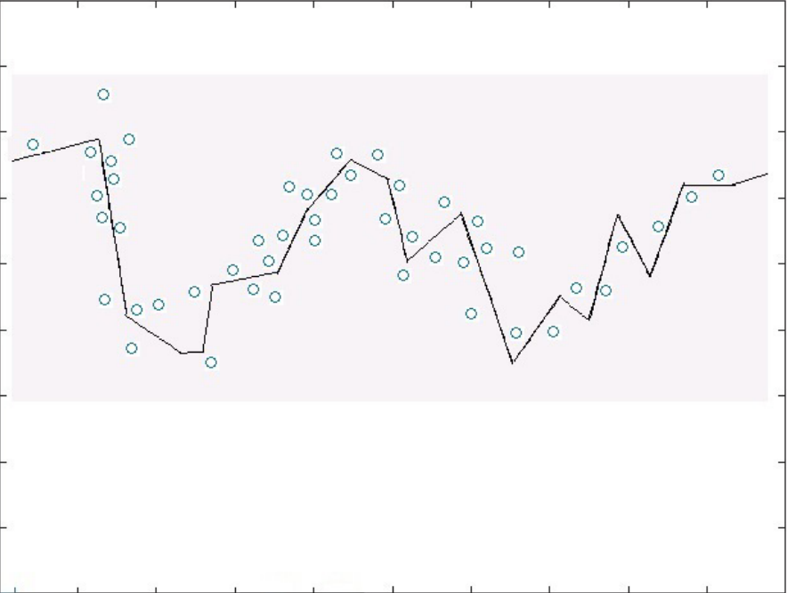

**Figure 1** The Addiction Function about the Time

We get the figure above through investigating the number of the game turns in each time moment by extracting 14400 data. We consider the more frequent people play the game in the moment, the less addictive the player who plays game in this moment is. And we use count backwards to get the figure about and get the function:

3.2 The Game Ranking according to Sociality

The time of gameplaying itself will affect the index of addiction.

Besides, we rank the games according to their sociality. We rank the different types of game into the table below:

**Table 1** The Ranking of Sociality for the Games

|  |  |  |
| --- | --- | --- |
| TYPE | VALUE | REASON |
| 1.ACT | 0 | It is a single game |
| 2.AVG | 0 | It is a single game |
| 3.PUZ | 0 | It is a single game |
| 4.CAG | 0 | It is a single game |
| 5.FTG | 0 | It is a single game |
| 6.MSC | 0 | It is a single game |
| 7.STG | 0 | It is a single game |
| 8.RPG | 0 | It is a single game |
| 9.TCG | 1 | It has a friend system, but not frequently used. |
| 10.RTS | 1 | It has a friend system, but not frequently used. |
| 11.SIM | 1 | It has a friend system, but not frequently used. |
| 12.TAB | 2 | It has a friend system, which is frequently used. |
| 13.SPG | 2 | It has a friend system, which is frequently used. |
| 14.SLG | 2 | It has a friend system, which is frequently used. |
| 15.FPS | 2 | It has a friend system, which is frequently used. |
| 16.MMORPG | 2 | It has a friend system, which is frequently used. |
| 17.moba | 2 | It has a friend system, which is frequently used. |

3.3 The Classify of the Games

For the different games have different patterns to gain the feeling of joy, we classify the games according to their length in time, the continuity and the repeatability.

**Table 2** The Classify of the Games

|  |  |
| --- | --- |
| Type | Continuity |
| 1.ACT | continuous |
| 2.AVG | continuous |
| 3.PUZ | discontinuous |
| 4.CAG | discontinuous |
| 5.FTG | discontinuous |
| 6.MSC | discontinuous |
| 7.STG | continuous |
| 8.RPG | continuous |
| 9.TCG | continuous |
| 10.RTS | discontinuous |
| 11.SIM | continuous |
| 12.TAB | discontinuous |
| 13.SPG | discontinuous/continuous |
| 14.SLG | discontinuous/continuous |
| 15.FPS | discontinuous |
| 16.MMORPG | discontinuous/continuous |
| 17.MOBA | discontinuous |

4. Model B: Establishment of the Index of Addiction

4.1 Model Overview

In our second model, we make an attempt to value the index of Addiction. It is relative to game time per day and the average game point the one gets. The more game time per day is, the more addicted to the game now. And the more the average game point is, the more likely to play again. By analyzing the 6.65 million data of the wordplay game, we figured out the Index of Addiction of 5000 individuals.

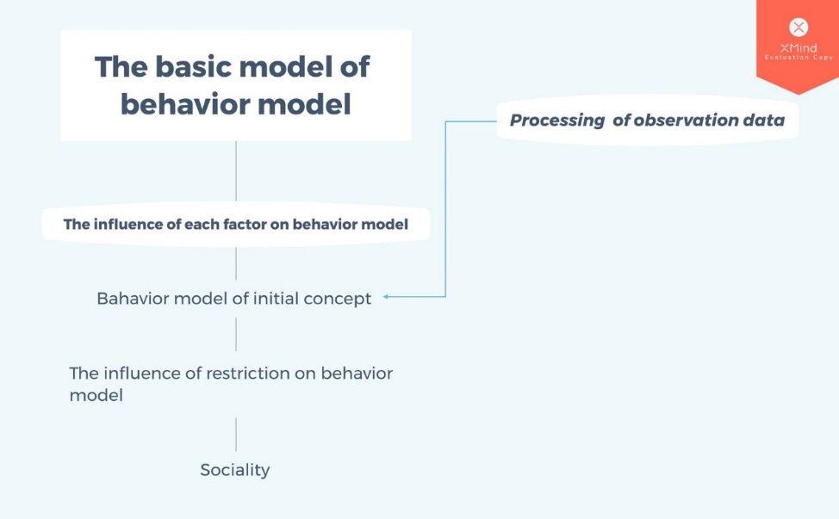

**Figure 2** The Mind Mapping

4.2 Variables of Model B

**Table 3** Variables of Model B

|  |  |
| --- | --- |
| Variables | Definition |
| *i*  j $p_{(j)}$   g  m  n | the status of an individual at n time  the status of an individual at (n+1) time  the probability of j=1  the maximum score of the individual  the minimum score of the individual  the average score of the 5000 individuals |

**4.3 The Index of Addiction**

In this section, we will define a discrete model to evaluate the behavior pattern of a player. We define an index to describe the possibility that he may continue playing game at a turn and calculate the sum of the possibility in a game of a point of time to qualify the player’s degree of addiction. In this way, we can get the compare the statue of players who don’t use the self-control mechanism and the ones who apply it and get the effect o the mechanism.

**4.3 .1 The Probability**

We define i as the status of an individual at n time, in which

i $∈\left\{0,1\right\}$

If i=0, it means that the individual is not playing the game. If i=1, it means that the individual is playing the game.

We can use i to predict the status of an individual at (n+1) time, which is j.

Then $p_{(j)}$ is used to describe the probability of j=1, in which

$\left\{\begin{aligned}p_{(n)}∈(0,1) \\ i,j ∈\left\{0,1\right\}\end{aligned}\right.$

$$p_{x,y}=\left[\begin{matrix}\begin{matrix}f_{1}(T) & 0 \\ 0 & f_{2}(t)\end{matrix} & \begin{matrix}0 & 0 \\ 0 & 0\end{matrix} \\ \begin{matrix}0 & 0 \\ 0 & 0\end{matrix} & \begin{matrix}f_{3}(k) & 0 \\ 0 & f_{4}(r)\end{matrix}\end{matrix}\right]$$

**4.3.2 The Factors of Addiction**

**4.3.2.1 Time**

The first factor of addiction is the start time and the duration time. Obviously, the time of playing can certainly influence the statue as who plays game for a longer time must be more addictive. Besides, the moment that the player plays also play a role in this evaluation, as a person who plays game at midnight instead of resting should be more addictive than a man spends the same time playing at evening. In this way, we can get the function figure of the relationship:

In this way, we can fit this function into the equation:

And we can get:

Besides, it’s relative to the length of the playing time itself. As a turn of game only takes 3.75 minutes, we get the evaluation model through:

$$f_{2}\left(t\right)=\frac{ln⁡(3.75)}{\ln\left(3.75\right)+ln⁡(n)}$$

**4.3.2.2 Competition**

The second factor of addiction is the goal in the game, such as the attempt of being the first in your city or in the whole world, which will activate curiosity. In our model, we thought that the player’s interest on the game should be negative with the highest score of the game’s record, as it can give the player the feeling of challenge and difficulty. Besides, it should also be negative with the distance between the player himself and the highest record, the difficult may make the player lose interest on the game. In this way, we get the evaluation equation:

$$f_{2}\left(k\right)=k∙\frac{I}{D^{2}}=k\sum_{i=1}^{n}{\frac{\left|{SC}_{A}-{SC}_{i}\right|}{S_{max}{（{SC}_{A}-{SC}_{i}）}^{2}}=k\sum_{i=1}^{n}{\frac{1}{{SC}_{max}\left|{SC}_{A}-{SC}_{i}\right|}}}$$

**4.3.2.3 Quality**

The third factor of addiction is the skill of the player, which contains the accuracy and score. In our consideration, the accuracy should be positive correlation with the addiction degree of the person, so we can get the expression:

$$\frac{∂s}{∂r}=ar^{α_{1}}$$

However, as the r is a possibility which is less than 1, the degree will decrease as the weight index $α_{1}$ increases. To solve the problem, we use the power of the natural constant to reflect the r’s effect:

$$\frac{∂s}{∂r}=ae^{r^{α_{1}}}$$

However, the score may affect the evaluation in another way. As a person started to play the game, he may be not willing to pay it much because of his low score which resulted from his poor quality. However, when he has played it for quite a little time, he can get used to it and become proficient. During this state, his willingness to play the game will certainly increase as he can gain more feeling of achievement from the game. Finally, as he keeps playing it for a long time and can’t improve more, he will be bored of it and the interest on the game would drop. In this way, we can get that the relationship of the player’s interest on a game and his quality which is reflected through the score can be pictured with the figure below:

$$\frac{∂s}{∂g}=ue^{\frac{g-m}{n}}$$

Then we can fit the function with the equation:

Finally, we get the relative function of this factor:

In addition, we normalized the data in the problem by following to eliminate the impact of the difference of the dimensions:

$$\frac{g-m}{n}$$

g stands for the maximum score of the individual, m stands for the minimum score of the individual. n stands for the average score of the 5000 individuals.

The comparing between two mechanisms

We use the AHP to get the weight of the functions, and get the weight matrix:

$$p_{\left(1\right)=}{\{α,β,ρ,θ\}}^{T}$$

And we get the Addiction index through:

$$P=\sum{P_{i}}$$

If the P is finally less than 0.5, we think that the person is more likely to stop playing than to continue as the self-control mechanism works.

5. Model C: Games with Networking

5.1 Model overview

In this model, we investigate the differences between short games with poor networking function and the games with strong networking function. Then, we give the strategy according to the different types of games.

5.2 Variables of Model C

**Table 4** Variables of Model C

|  |  |
| --- | --- |
| Variables | Definition |
| $u_{1}$ $$u_{2}$$ $u_{3}$ $$S_{i}(n)$$ $r_{ij}$ | the factor of entertainment  the factor of health  the factor of social  the evaluation function  the degree of membership of $u_{i}$ to $v_{j}$ |

5.3 Social factors

We will discuss how to make it a best strategy to set the self-control in a continuous and short game. As far as we concerned, the players are mainly harmed by the Computer radiation. The harm dose an effect every second that the player is exposed to the radiation, and we can get that the harm of the radiation should be linear relative to the playing time.

$$H={1-k}_{1}t$$

In this equation, we normalize 300 minute as 1.

Then we will discuss the best game-playing time for a payer to get the best experience from the game. The player’s sense of satisfaction and joy mainly from his reap in the game. As the time goes, the ration of the players should decrease for his tiredness and weary. So we get the relation equation of the time and the players’ reap:

$$R=1-k_{2}t$$

Generally, the more a player gets, the more satisfied he will be. In this way, the satisfaction of a player in the moment T should be relative with the sum reap in this turn f game. In this way, we calculate the satisfaction degree of a player through the equation:

$$Satisfaction=\int_{0}^{End Time}{Rdt}$$

And then we calculate the total quantity of the satisfaction of a player by integrating this function over time:

$$Total Satisfaction=\int_{0}^{End Time}{\int_{0}^{End Time}{Rdtdt}}$$

According to the China’s national regulations, the length of 3 hours is the optimum game length for regular players to balance the harm of computer radiation and the game satisfaction. In this way,

$$Q=\int_{0}^{180}{\int_{0}^{180}{1-k_{2}t}}+\int_{0}^{180}{{1-k}_{1}tdt}$$

As it’s a continuous and poor-networking game, the players mainly get their interest from the game itself.

And we get the best value for k is $\frac{1}{270}$

5.4 Continuous and Social

As it’s a continuous and poor-networking game, the players mainly get their interest from the game itself. Comparing to the continuous and poor-social games, the extra factor of the continuous games with strong networking function is the sociality. However, this function isn’t numerical and easy to qualify. In this way, we use the comprehensive fuzzy evaluation method. The comprehensive fuzzy evaluation method uses the accurate data to deal with the fuzzy object and gets a reasonable quantitative evaluation closing to the reality.

First, we ascertain the factor sets. As we have investigated in the sub model above, we can easily get the factor set:

$$V=\left\{u_{1},u_{2},u_{3}\right\}$$

In which:

$$\left\{\begin{aligned}u_{1}=1-kt \\ u_{2}=1-t \\ u_{3}=n\end{aligned}\right.$$

The n is the ranking level in our preparation.

Then, we ascertain the evaluation set for the game. We rank the experience degree into 5 levels.

**Table 5** The Level of the Evaluation Elements

|  |  |  |  |
| --- | --- | --- | --- |
| $$v_{1}$$ |  | extremely bad experience | 0 |
| $$v_{2}$$ |  | Poor experience | 0.25 |
| $$v_{3}$$ |  | Medium experience | 0.5 |
| $$v_{4}$$ |  | Good experience | 0.75 |
| $$v_{5}$$ |  | Excellent experience | 1 |

So we get the evaluation set and the unit evaluation space:

$$V=\left\{v_{1},v_{2},v_{3},v_{4},v_{5}\right\}$$

Besides, we ascertain the weight of the three factors. We define the step A as the vector of weight and build the fuzzy relation equation:

$$AW=B$$

In which:

$$A=\left\{a_{1},a_{2},a_{3}\right\}$$

$$W={\left\{u_{1},u_{2},u_{3}\right\}}^{T}$$

The W is the transposed matrix of factor set V and the B is the fuzzy solution result in this evaluation space. We can get the B through the equation:

$$B=\left\{b_{1},b_{2},b_{3},\right\}$$

In which: $$b_{i}=\frac{d_{i}*v_{i}}{\sum_{1}^{3}{d_{i}*v_{i}}}$$

$$d_{i}=1Λ[1-u_{i}+v_{i}]$$

We get the solution result for the equation through the least square method and get the A.

Then we normalize the weight A:

$$a^{*}=\frac{a_{i}}{\sum_{1}^{3}{a_{i}}}$$

However, the result $a_{i}$ may be less than 0. In order to deal with such a problem, we build another matrix T:

$$T=\left\{t_{1},t_{2},t_{3}\right\}$$

In which:

$$t_{i}=a_{i}+(A_{max}-A_{min})$$

And we calculate the $t^{*}$ in the same way with $a_{i}$

Then we will do the single factor fuzzy evaluation. We build the evaluation matrix R:

$$R=\left[\begin{matrix}r_{1_{1}} & ⋯ & r_{1_{5}} \\ ⋮ & ⋱ & ⋮ \\ r_{3_{1}} & ⋯ & r_{3_{5}}\end{matrix}\right]$$

In this matrix, the element r represents the membership degree of the factor $u_{i}$ to the rank $v_{i}$.

In order to eliminate the impact of the different dimensions, we normalize the $r_{i_{j}}$:

$$r_{i_{j}}=\frac{\frac{\sum_{i=j=1}{u_{i}-v_{j}}}{u_{i}-v_{j}}}{\sum_{i=j=1}{\frac{\sum_{i=j=1}{u_{i}-v_{j}}}{u_{i}-v_{j}}}}$$

Then we calculate the Fuzzy comprehensive evaluation result vector:

$$F=A*R$$

When the f is at its maximum, the k is the optimum degree for the game to set.

Then we will discuss the games have both continuous and repetitive elements. Such online games such as WOW have a lot of social and personal factors such as players’ competition, the game instances, ranking system, socializing. We will also evaluate such games from these aspects.

In this way, we do an experiment on the game Clash of Kings and get the optimum k for it is $\frac{1}{228.26}$.

5.5 Life Span

First, we quantify the impact of Self-Control Mechanism

$$f\left(x\right)=px$$

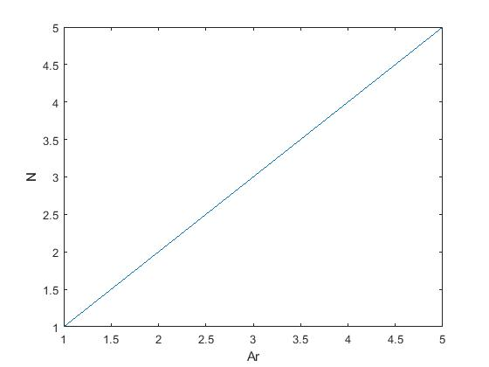

**Figure 3**

$$\int{f\left(x\right)}+\int{f\left(s\right)}$$

$$f\left(x\right)=px$$

Since the Self-Control Mechanism will influence the skill and the Feeling of freshness, which will finally influence the life span of the game.

If we don’t play the game at that moment, the function of skill will be

$$ke^{-t}$$

If we don’t play the game at that moment, the function of skill will be

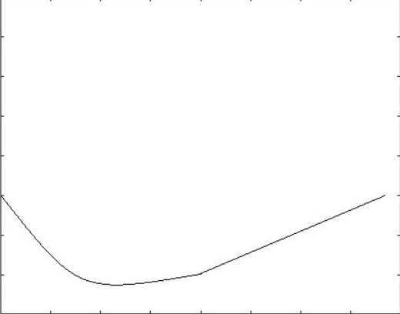

**Figure 4**

$$ke^{-t}$$

If we play the game at that moment, the function of skill will be

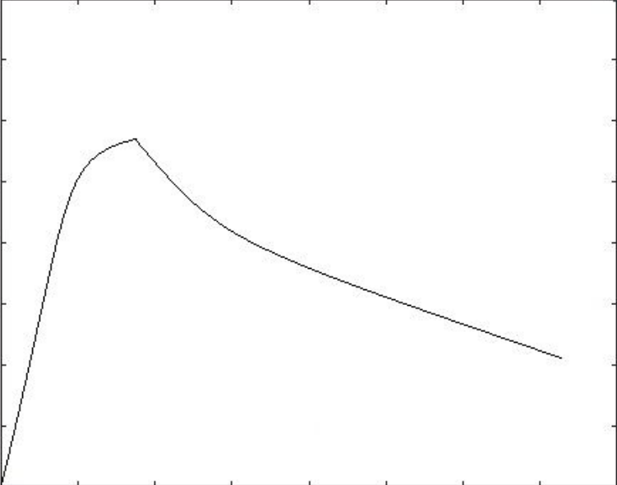

**Figure 6**

$$nIn(t+1)$$

If we don’t play the game at that moment, the function of Feeling of freshness will be

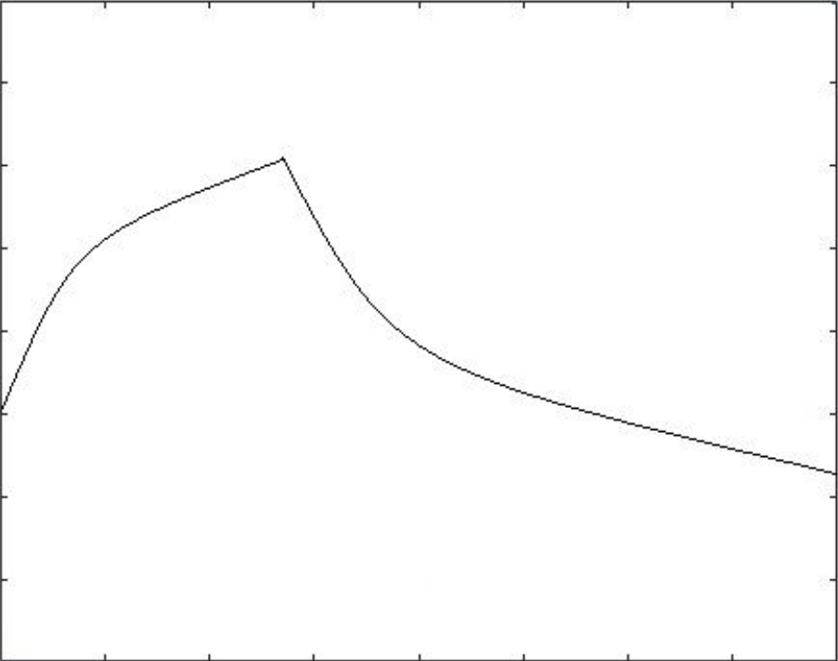

**Figure 7**

$$ke^{-t}$$

If we play the game at that moment, the function of Feeling of freshness will be

n+qt

The Self-Control Mechanism will have negative impact in short term, and positive impact in long term.

6 Sensitive analysis

6.1 Sensitivity of tq

It is a very smooth curve, which fits our expectation.

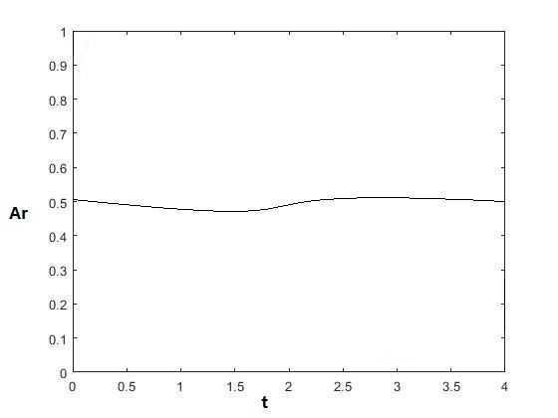

**Figure 8**

It is a very smooth curve, which fits our expectation.

6.2 Sensitivity of tar

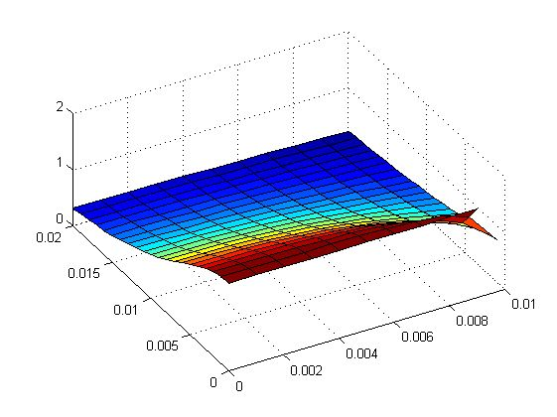

**Figure 9**

7. Strengths and weaknesses

7.1 Strengths

**1. Our model works steadily.**

Sensitivity analysis shows that our model is not easily disturbed by changes in its constants. Therefore, its results are relatively steady and reliable.

**2. Our model works ideally.**

The prediction given by our model ideally corresponds with mainstream points. In addition, there SA validate the stability of our model.

7.2 Weaknesses

**1.Our model involves a large operand**.

As our model involves huge amounts of data, the amount of calculation we need to conduct becomes enormous. This makes our model slow to operate and dependent on the quality of hardware.

**2. Our model relies on large amounts of data.**

To operate our model, great amounts of data are needed. When appropriate data is scarce, our model would be unable to function.

8.References

[1] Lili Wang, Qiang He, Fen Li(2011). Contemporary Economics. Qingdao University of Technology. 266520

[2] *http://data.stats.gov.cn*

9.A Proposal letter to a Game Production Company

November, 20, 2018

Blizzard Entertainment

[Irvine](https://en.wikipedia.org/wiki/Irvine,_California), [California](https://en.wikipedia.org/wiki/California),

U.S

Dear Blizzard Entertainment committees,

It is with much pleasure and enthusiasm that I am writing to you to give advice on The Self-Control Mechanism in the game called World of Warcraft. Our work is based on mathematical modeling. The work involves Fuzzy relation equation.

Then we discuss the set of the self-control mechanism in different types of games according to our classifying in our model A. We dividedly investigate the interest of these games. We consider the harm of the computer radiation and the joy the players get and research the optimum mechanism to change the reap that the players gain in the games to work as a nudge to incentivize the players’ self-control.

Finally, we do the sensitivity analyses to show the robustness of the models.

Please let me know if there’s any additional information that we can provide to support you. Please think carefully of our advice.

Sincerely,

A group of mathematical modeling lovers